Documentation of Deploymet Wechat

1. Do docker hub login on terminal

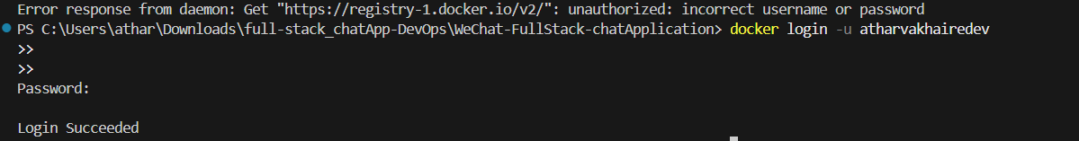

1. Start minikube

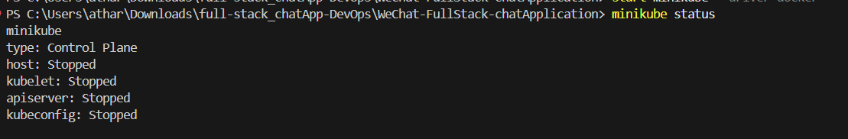



1. Created k8s folder for all kubernates yaml configurations

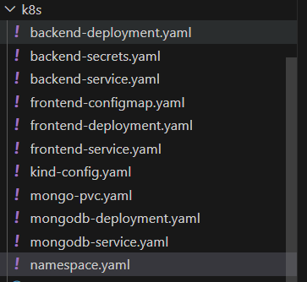

We need all this configuration.



1. Create build of frontend and backend both and push image to dockerhub
2. Running all deployments , services for backend , frontend and mongodb

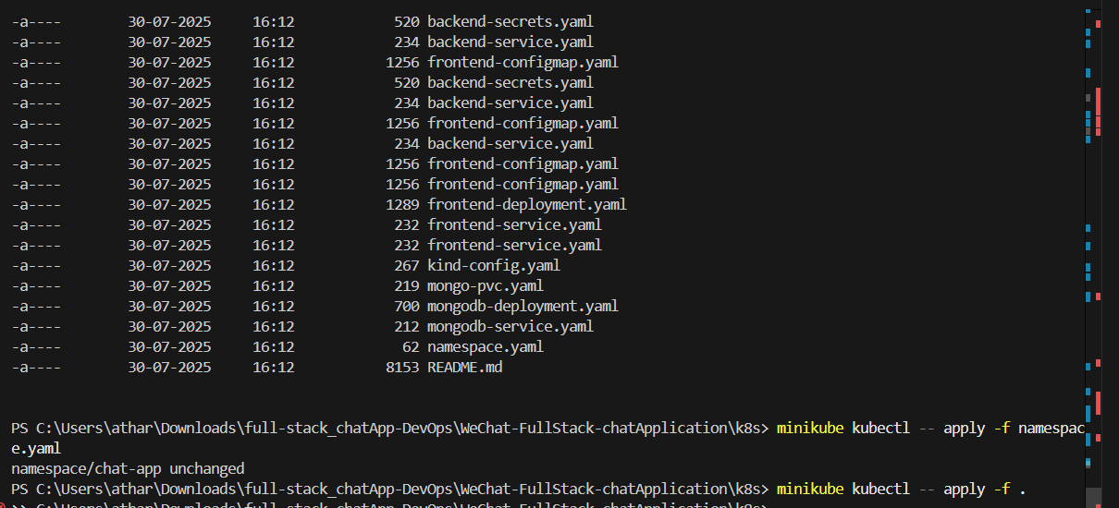

1. Now all pods are running

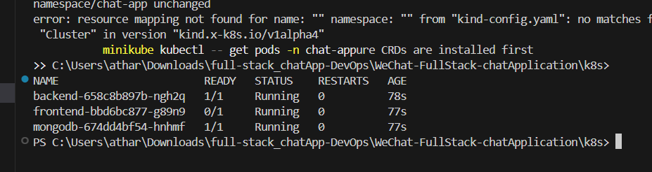

Look like this

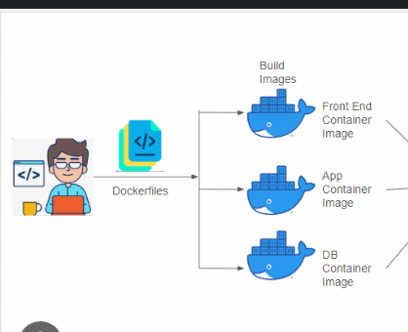

1. kubectl port-forward svc/backend 5001:5001 -n chat-app
2. kubectl port-forward svc/frontend 8080:80 -n chat-app
3. kubectl port-forward svc/mongodb 27017:27017 -n chat-app